The Intern Academy

Data Science & Machine Learning Tasks

TASK 1:

Problem Statement:

Sales management has gained importance to meet increasing competition and the need for improved methods of distribution to reduce cost and to increase profits. Sales management today is the most important function in a commercial and business enterprise.

Do ETL : Extract-Transform-Load some Amazon dataset and find Sales-trend -> month wise , year wise , yearly month wise. Find key metrics and factors and show the meaningful relationships between attributes. Do your own research and come up with your findings.

Report After Analysis

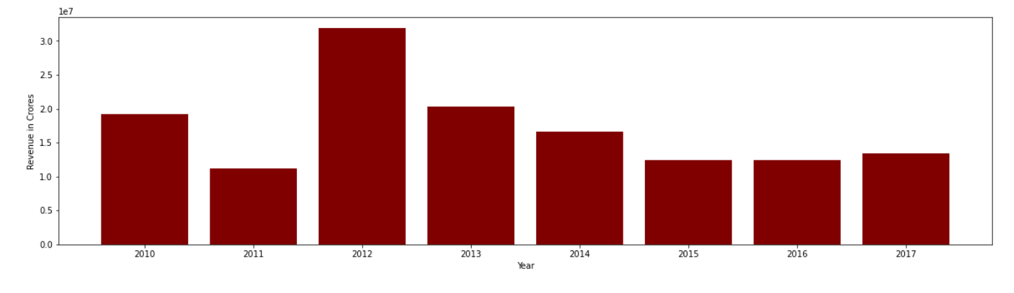

We took the file 100 Sales Records.csv and analyzed it with jupyter notebook. This bar graph shows revenue in crores year after year. Year 2012 was very profitable(more than 3cr) for company but there was a steady decline afterwards and remained constant after year 2015 at just 1cr.

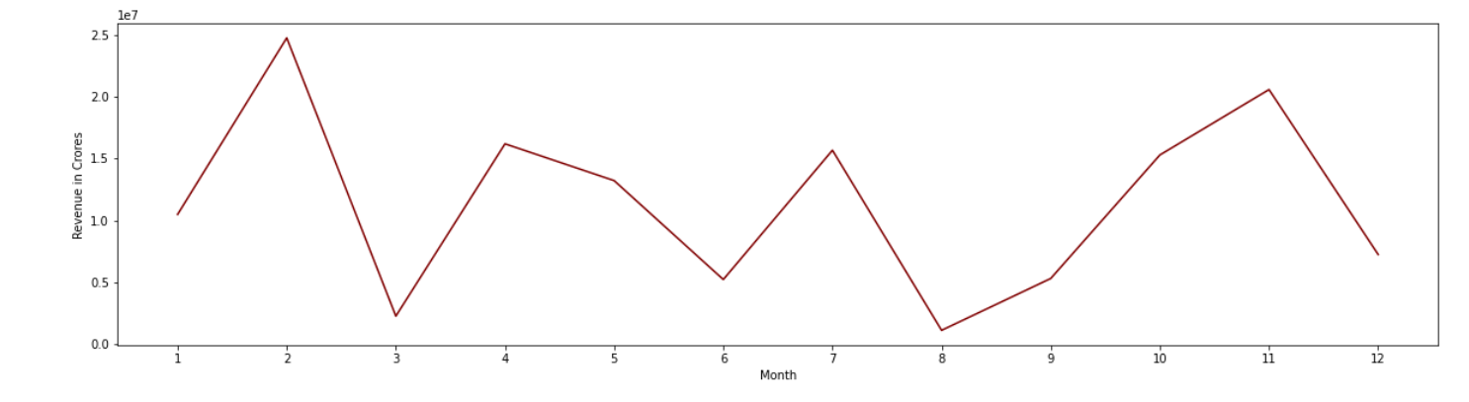

This graph shows Revenue in crores and month wise distribution. Month of March had profits less than 0.5 cr and after 8th month there was steady inclination of profit till 11th month where again Revenue declined.

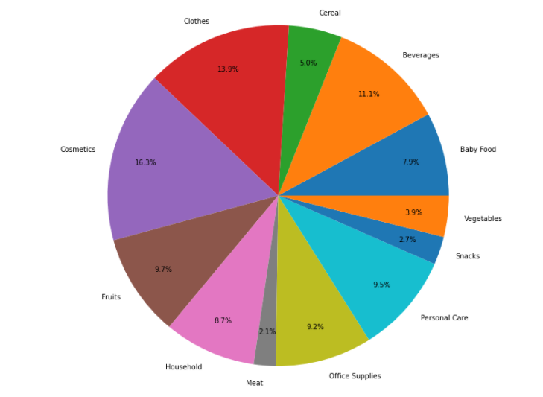

This pie chart show the total units sold and we can interpret that cosmetics(16.3%) was largest selling category, while meat category (2.1%) was least selling.

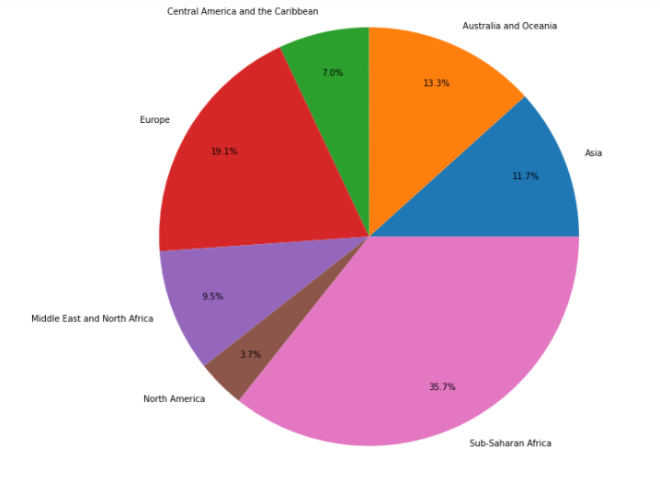

This pie chart show the total units sold region wise and sub-saharan Africa(35.7%) was most selling region and Northern America (3.7%) was least selling region.

These are monthly yearly reports of units sold: 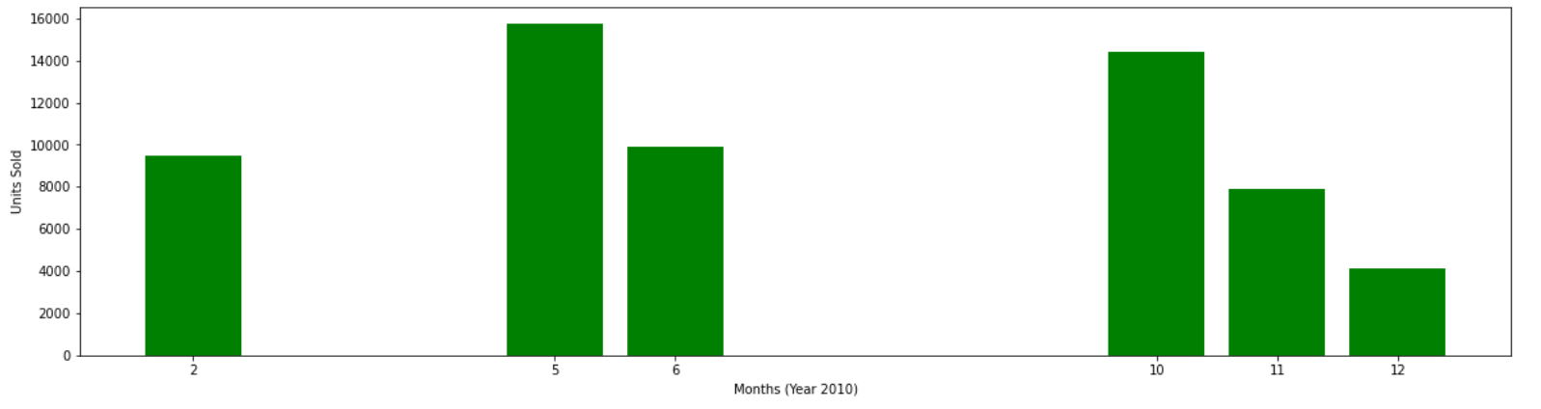

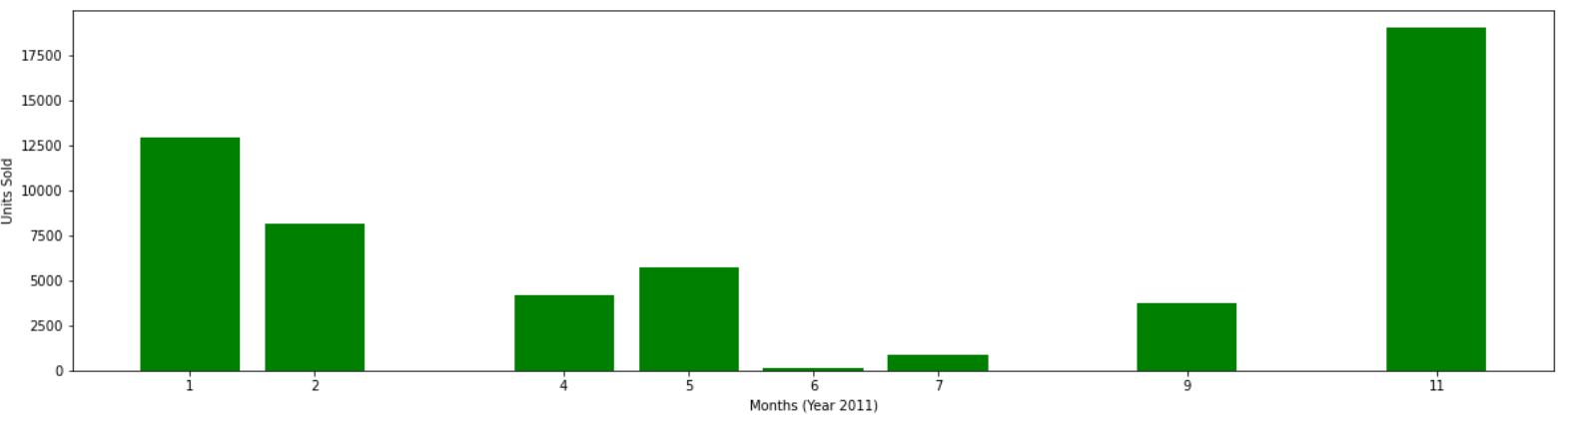 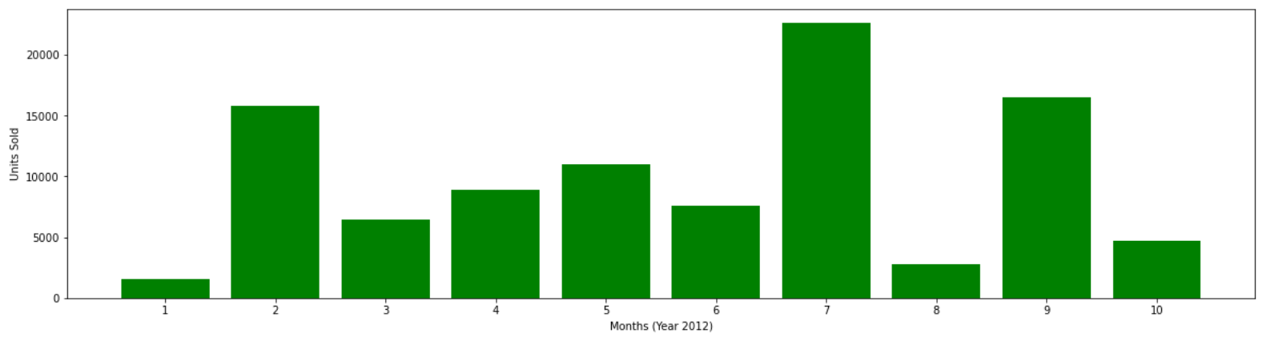

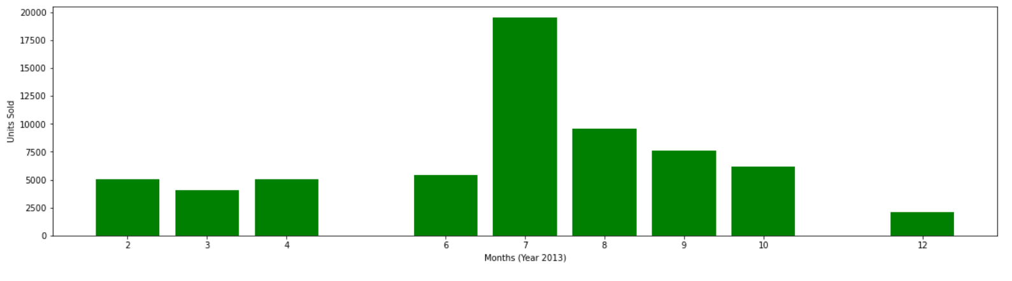 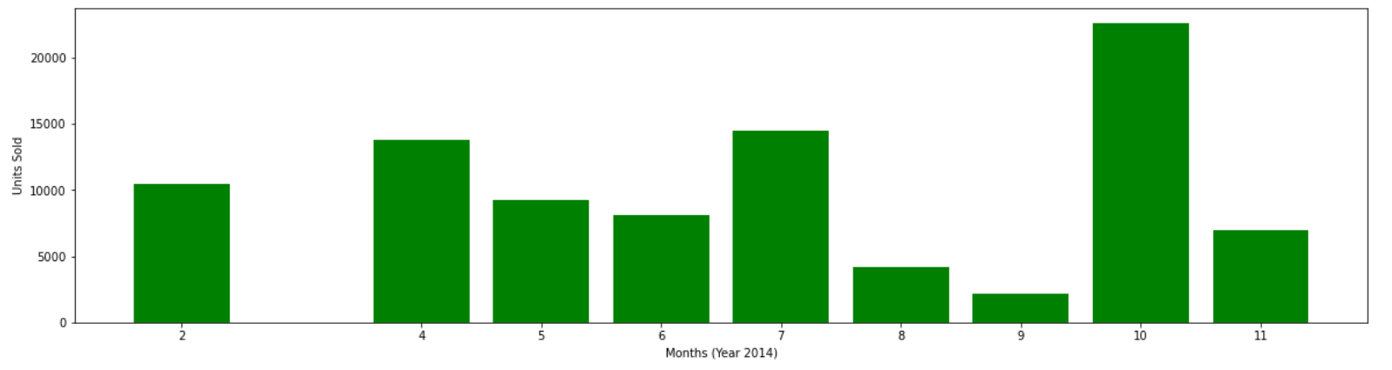 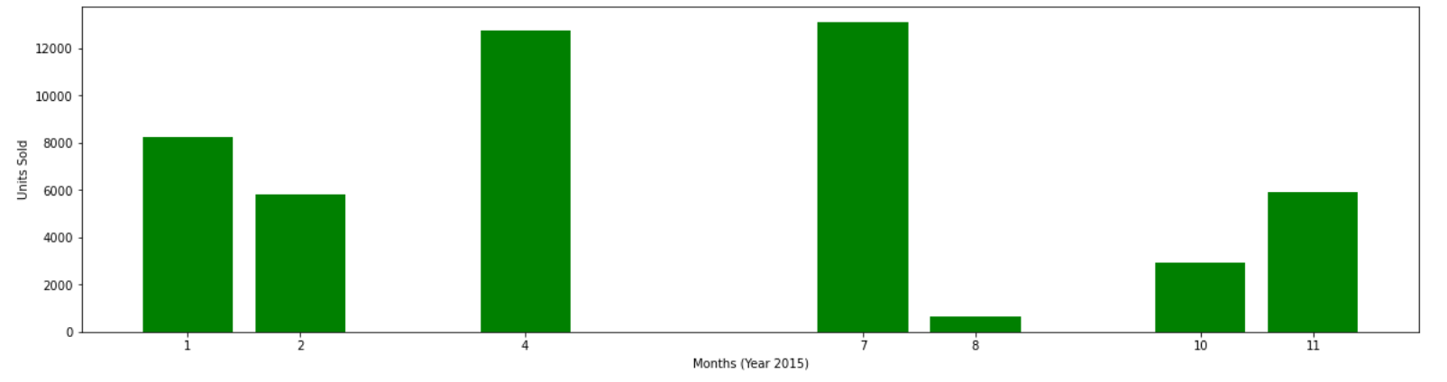 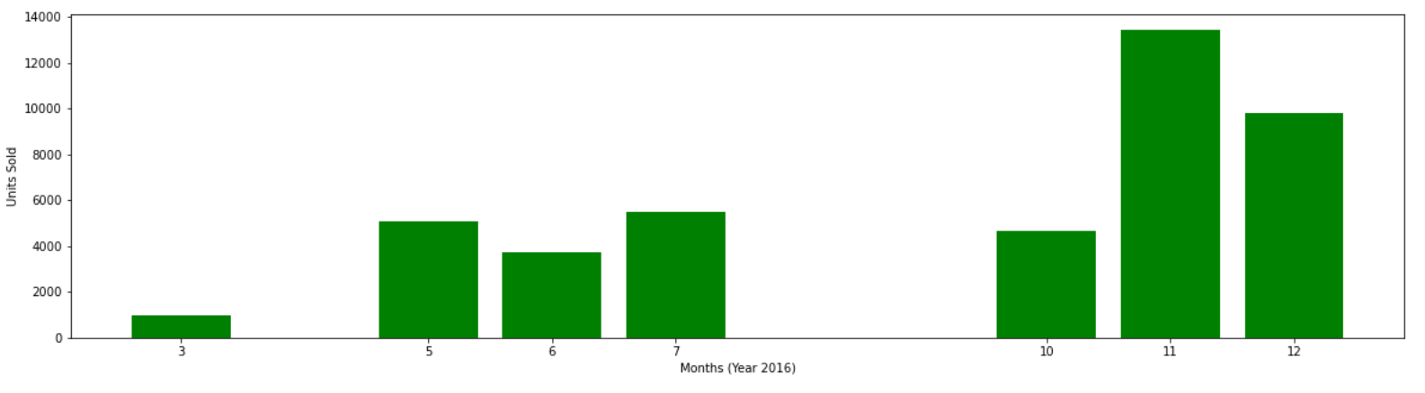 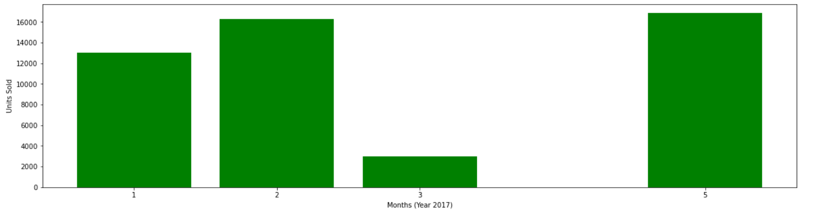

These bar graph denotes Total profit and Total cost.

Office supplies, household and cosmetics are some category that prove to be very profitable.

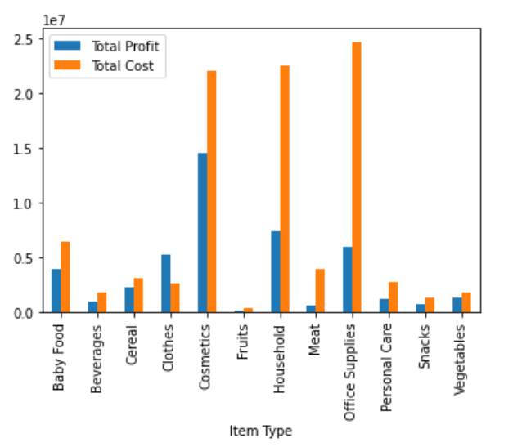

This graph shows the price and cost for unit product. We can analyze that fruits and beverages are giving very low profits and may run into loss.

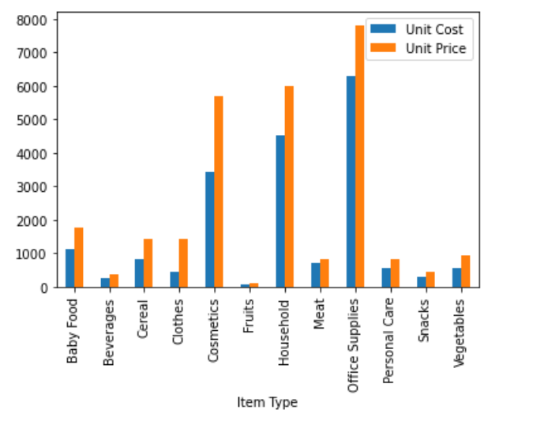

Submitted by Team:

Janhvi Somani

Rohan Mehta

Sarvesh Patil